**EXPERIMENT 8**

**SAILOR BOAT DATABASE (DDL, DML, DQL, Subquery, Joins, Set operations)**

**Aim:**

• Create sailors, boats, and reserves.(foreign key)

• Insert 5 values each table.

• Display all records.

• Find the names and ages of all sailors.

• Find all sailors with ratings above 8.

• Find sailors name with rating above 7 & age above 25.

• Display all the names & colors of the boats.

• Find all the boats with Red colors.

• Find the names of sailors' who have reserved boat number 103.

• Find the sids of sailors who have reserved blue boat

• Find the names of sailors' who have reserved Red boat.

• Find the colours of boats reserved by some name(provide any name in table).

• Find the names of the sailors who have reserved at least one boat.

• Find the names of the sailors who have reserved two different boats.

• Find the names of sailors who have reserved a Red or a Green boat.(union)

• Find the names of sailors who have reserved both a Red and a Green boat.

• Find the names of sailors who have reserved boat 103.(nested query)

• Find the names of sailors who have reserved red boat.(nq)

• Find the names of sailors who have not reserved red boat.(nq)

• Find the names of sailors who have reserved boat number 103.(exists)

• Find sailors whose rating is better than some sailors called name.

• Find sailors whose rating is better than every sailor' called name.

• Find the sailors with highest rating.

• Find the average age of all sailors.

• Find the average age of sailors with a rating of 10.

• Count the number of sailors.

• Count the number of different sailor ratings.

• Find the name and age of the oldest sailor.

• Find the names of the sailors who are older than the oldest sailor with a rating of 10.

• Find the age of youngest sailor for each rating level.

• Find the age of the youngest sailor who is eligible to vote (i.e., is at least 18 years old) for each rating level with at least two such sailors.

• For each red boat, find the number of reservations for this boat.

• Find all sailors name according to names.

• Find all sailors details according to rating.

• Find all sailors details according to rating(highest first) if ratings are same then according to age(youngest first).

**Code:**

CREATE SCHEMA Sailors;

1)CREATE TABLE sailors(sid integer, sname varchar(30),rating integer, age real,primary key(sid));

CREATE TABLE boats(bid integer, bname varchar(30),color varchar(20),PRIMARY KEY (bid));

CREATE TABLE reserves(sid integer, bid integer, day date,foreign key(sid) references sailors(sid),foreign key(bid)references boats(bid));

desc sailors;

desc boats;

desc reserves;

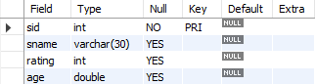

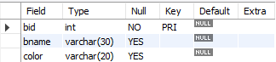

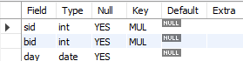

2)Insert into sailors values(22,'Dustin',7,45.0),(29,'Brutus',1,33.0),(31,'Lubber',8,55.5),(32,'Andy',8,25.5),(58,'Rusty',10,35.0);

insert into boats values(101,'Interlake','blue'),(102,'Interlake','red'),(103,'Clipper','green'),(104,'Marine','red');

insert into reserves values(22,101,'98-10-10'),(22,102,'98-10-10'),(22,103,'98-8-10'),(22,104,'98-7-10'),(31,102,'98-10-11');

3)select * from sailors;

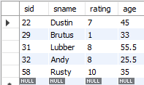

select * from boats;

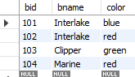

select * from reserves;

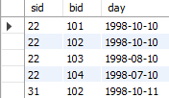

4)select sname,age from sailors;

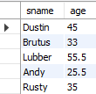

5)select * from sailors where rating>8;



6)select sname from sailors where rating>7 and age>25;

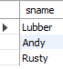

7)select bname,color from boats;

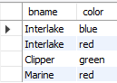

8)select * from boats where color='red';

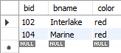

9)select s.sname from sailors s, reserves r where s.sid=r.sid and r.bid=103;



10) select s.sid from sailors s,reserves r,boats b where s.sid=r.sid and r.bid=b.bid and b.color="blue";



11) select s.sname from sailors s,reserves r,boats b where s.sid=r.sid and r.bid=b.bid and b.color="red";

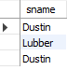

12) select b.color from sailors s,reserves r,boats b where s.sid=r.sid and r.bid=b.bid and s.sname='Dustin';

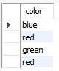

13) select distinct s.sname from sailors s,reserves r where s.sid=r.sid ;



14)select distinct S.sname from sailors S, reserves R1, reserves R2 where S.sid=R1.sid and S.sid=R2.sid and R1.bid<>R2.bid;



15)select S.sname from sailors S,reserves R,boats B where S.sid=R.sid and R.bid=B.bid and B.color='red' union select S.sname from sailors S,reserves R,boats B where S.sid=R.sid and R.bid=B.bid and B.color='green';



16) select S.sname from sailors S,reserves R1,boats B1,reserves R2,boats B2 where S.sid=R1.sid and R1.bid=B1.bid and S.sid=R2.sid and R2.bid=B2.bid and (B1.color='red' and B2.color='green');



17) select s.sname from sailors s where s.sid IN ( SELECT r.sid FROM reserves r WHERE r.bid = 103 ) ;



18) select s.sname from sailors s where s.sid IN (select r.sid from reserves r where r.bid in (select b.bid from boats b where b.color='red'));



19) select s.sname from sailors s where s.sid NOT IN (select r.sid from reserves r where r.bid in (select b.bid from boats b where b.color='red'));

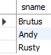

20) select s.sid from sailors s where exists(select * from reserves r where r.bid=103 and r.sid=s.sid);



21) select s.sid from sailors s where s.rating > ANY (select s.rating from sailors s where s.sname = 'Dustin' );

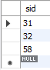

22) select s.sid from sailors s where s.rating > all (select s.rating from sailors s where s.sname = 'Dustin' );



23) select s.sid from sailors s where s.rating >= all (select s.rating from sailors s );



24) select avg(age) from sailors;



25) select avg(s.age) from sailors s where s.rating = 10;



26) select count(sid) from sailors;



27) select count(distinct rating) from sailors;



28)select s.sname,s.age from sailors s where s.age= (select max(s.age) from sailors s);

29) select s.sname from sailors s where s.age>all(select max(s.age) from sailors s where s.rating=10 );



30) select s.rating, min(s.age) from sailors s group by s.rating;

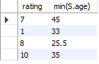

31) select s.rating, min(s.age) from sailors s where s.age >= 18 group by s.rating having count(*) > 1;



32) select B.bid,count(*) from boats B,reserves R whereE R.bid=B.bid AND B.color='red' group by B.bid;



33) select s.sname from sailors s order by s.sname;

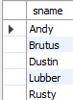

34) select * from sailors s order by s.rating;

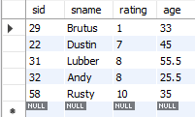

35) select * from sailors s order by s.rating desc,age asc ;

